Milestone 03

**Verify the key-user flow(s)**

**User Experience Engineering – IT3050**

B.Sc. (Hons) in Information Technology

Group: SEJ008

Sustainable Development Goal: Zero Hunger

App Name: Kill Hunger

|  |  |
| --- | --- |
| **Student ID** | **Student Name** |
| IT20137250 | Rajapaksha R.C.P |
| IT20230692 | S.C.S.Arachchi |
| IT20660352 | P.L.P.G.D.S.Wijesooriya |
| IT20666538 | M.G.W. Bhagya |

Table of Contents

Animal Right Activist’s (IT20137250) 2

Fail-Points/Blockings 2

updated user flow according to Animal Activists requirements 5

User flow 2- 6

User flow 3- 7

Children’s Warden (IT20230692) 8

Fail-Points/Blockings 8

updated user flow according to warden’s requirements 11

User flow 2- 12

User flow 3- 13

Food Donor (IT20660352 ) 14

Fail-Points/Blockings 14

User flows 2/3 – 16

Article Author (IT20666538 M.G.W Bhagya) 17

Fail-Points/Blockings 17

According to Un-Modify User Flow 20

Updated User Flow 21

User Flow 2- 22

User Flow 3 – 23

# **Animal Right Activist’s (IT20137250)**

## **Fail-Points/Blockings**

1. It does not include if logging failed part.

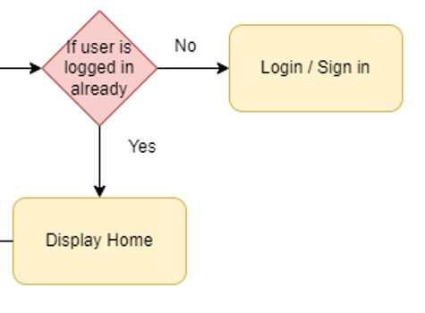

1. It does not include the contact donor details view section.

1. It does not include the choose location option to find donation foods easily.

## **updated user flow according to Animal Activists requirements**

## **User flow 2-**

**

## **User flow 3-**

**Give feedback for donors**

# **Children’s Warden (IT20230692)**

## **Fail-Points/Blockings**

1. does not include if logging failed part.

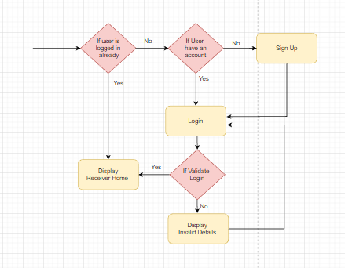

1. 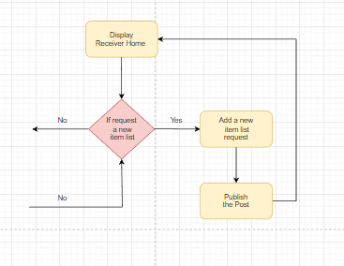Does not include part of the request approved section.

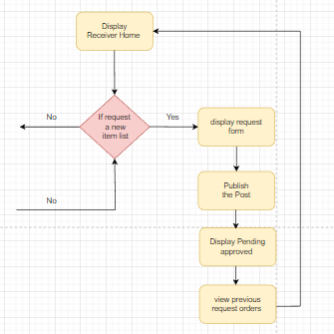

1. Does not include the search option to easily find donation items

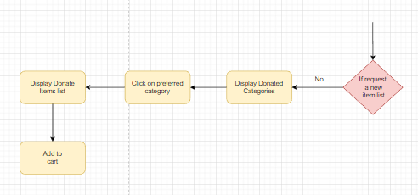

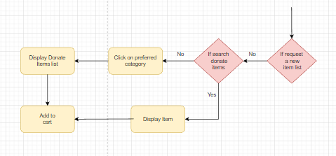

## **updated user flow according to warden’s requirements**

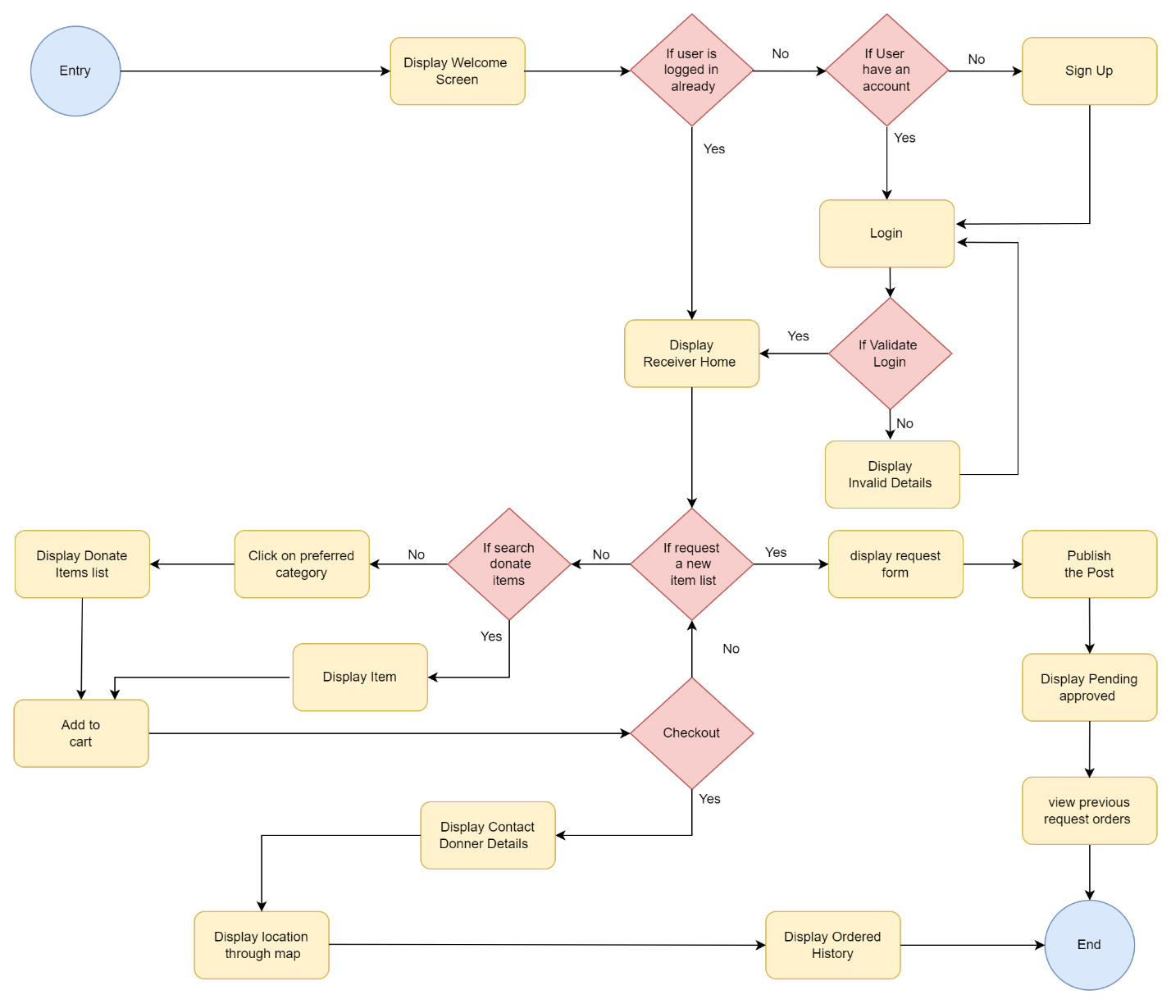

## **User flow 2-**

Update Receivers' requests before approval from the admin.

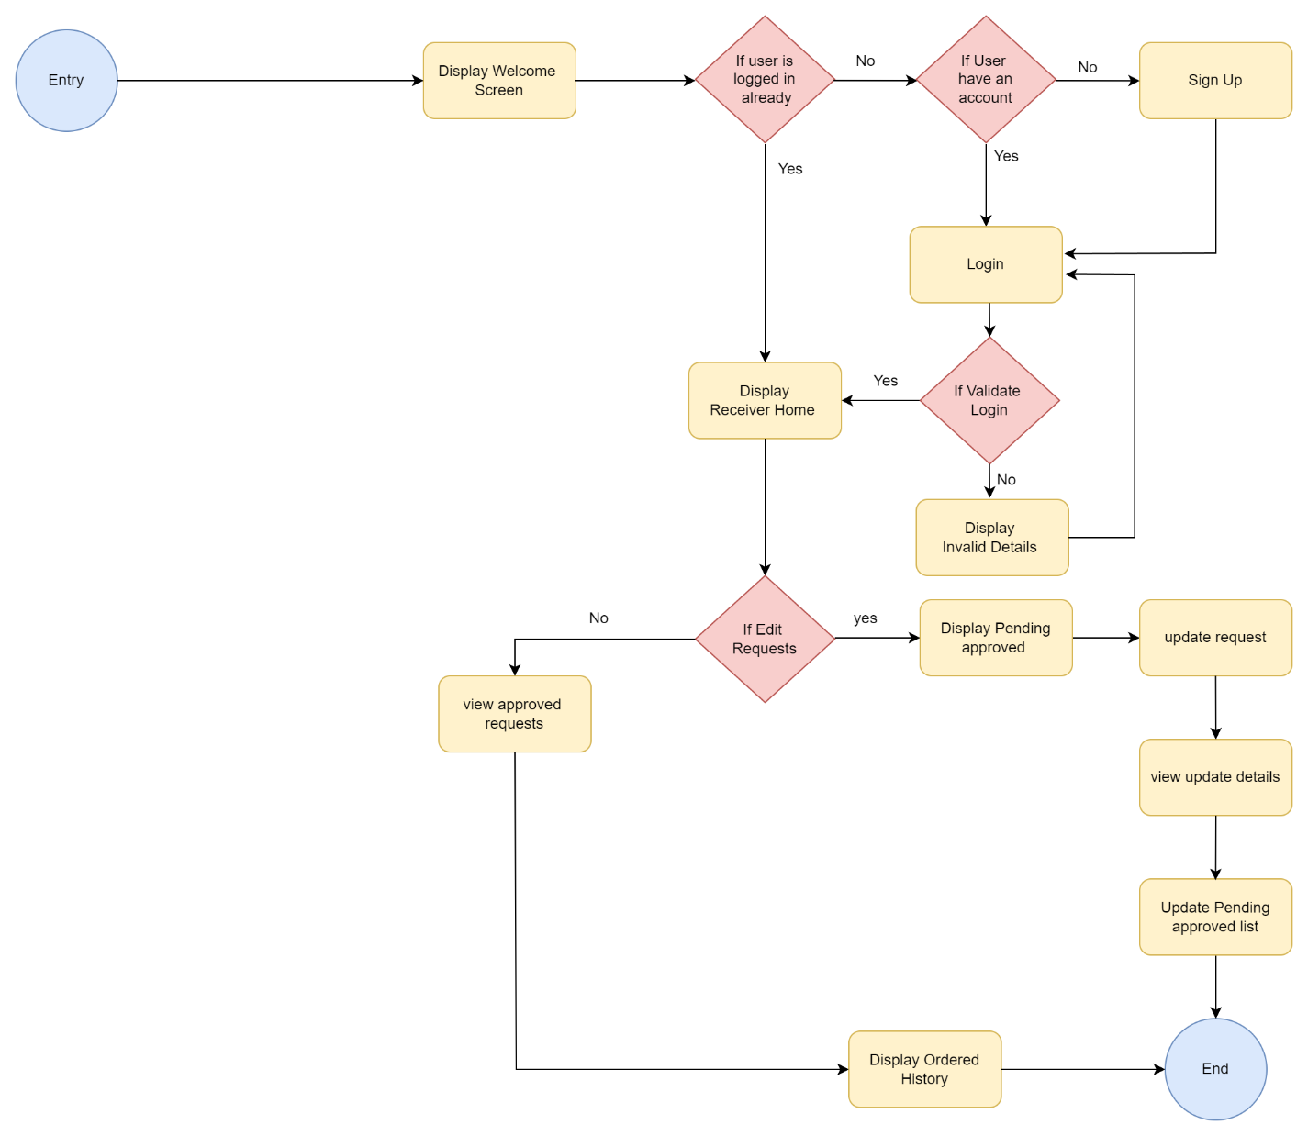

## **User flow 3-**

give feedback for donners

# **Food Donor (IT20660352 )**

## **Fail-Points/Blockings**

1. Before, a food donation should be deleted or updated by selecting it from the food donation list page, now it can be searched and found and deleted or updated

2. Previously, the facility to manage the food donor's profile was missed and later it was added.

## **Chart, diagram, box and whisker chart Description automatically generatedUser flows 2/3 –**

# **Article Author (IT20666538 M.G.W Bhagya)**

## **Fail-Points/Blockings**

1. **Does not include if logging failed part and If any Un-Registered writer trying to login to the system before user flow there is no option for them.**

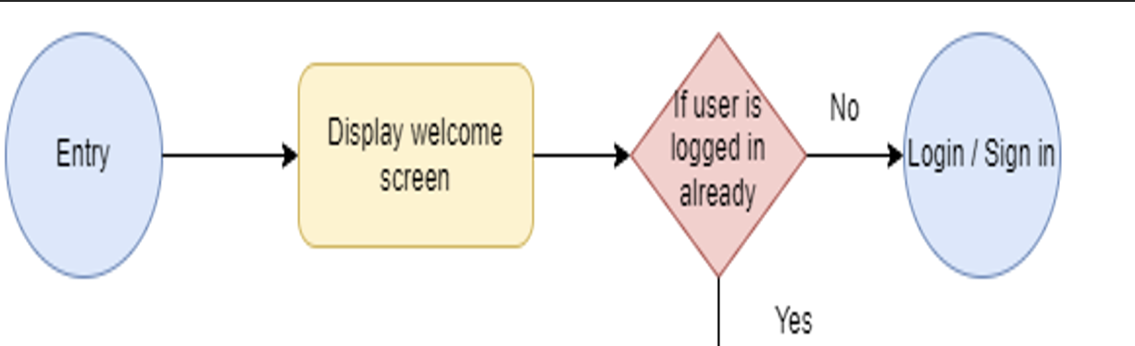

1. **Before, there was no option to view article author’s profiles. Now Profile viewing option provided.**

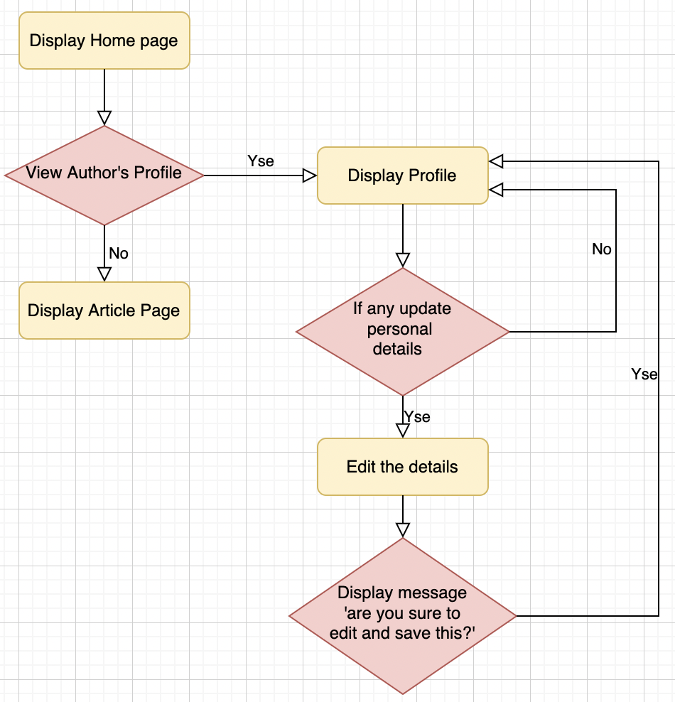

**3.Before, After write an article and edit or delete the article any time article author can do it.Now approval must be needed to make it done.**

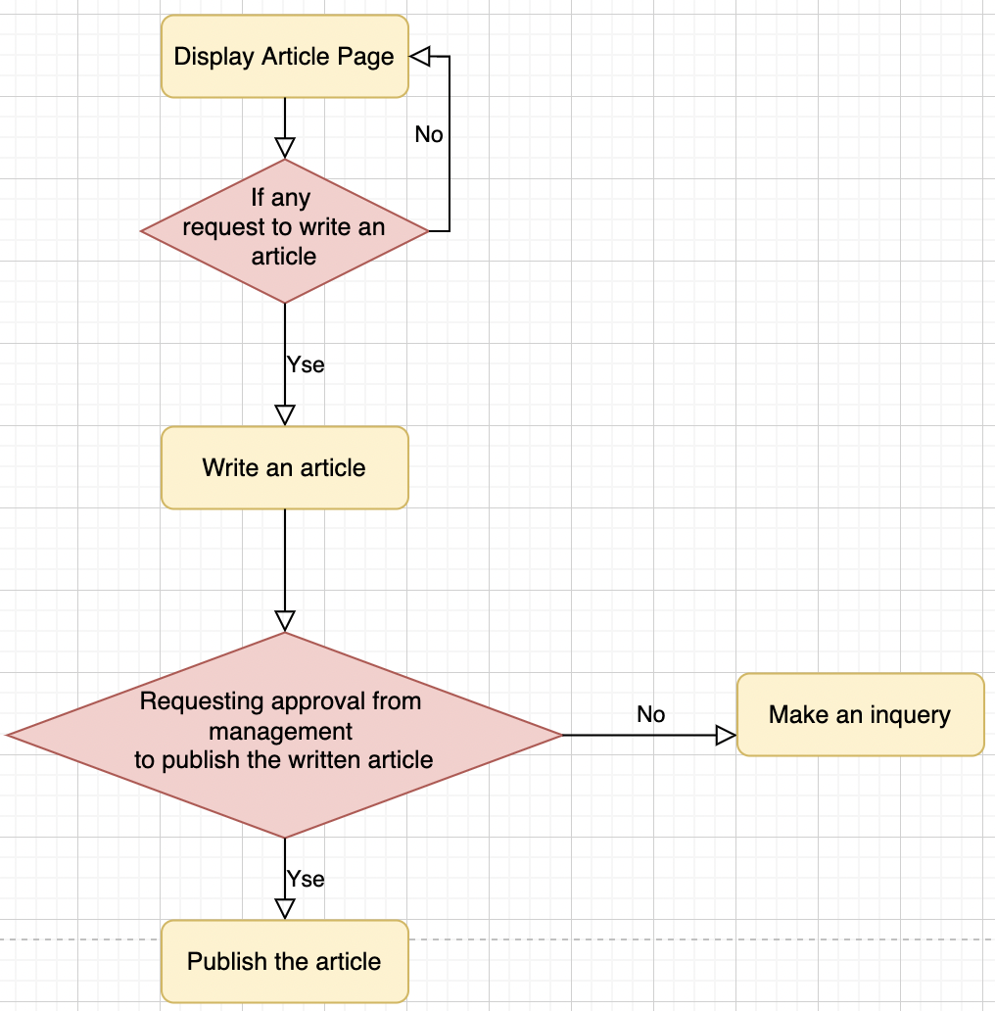

## **According to Un-Modify User Flow**

## **Updated User Flow**

## **User Flow 2-**

**Search Function for Reader and Writer**

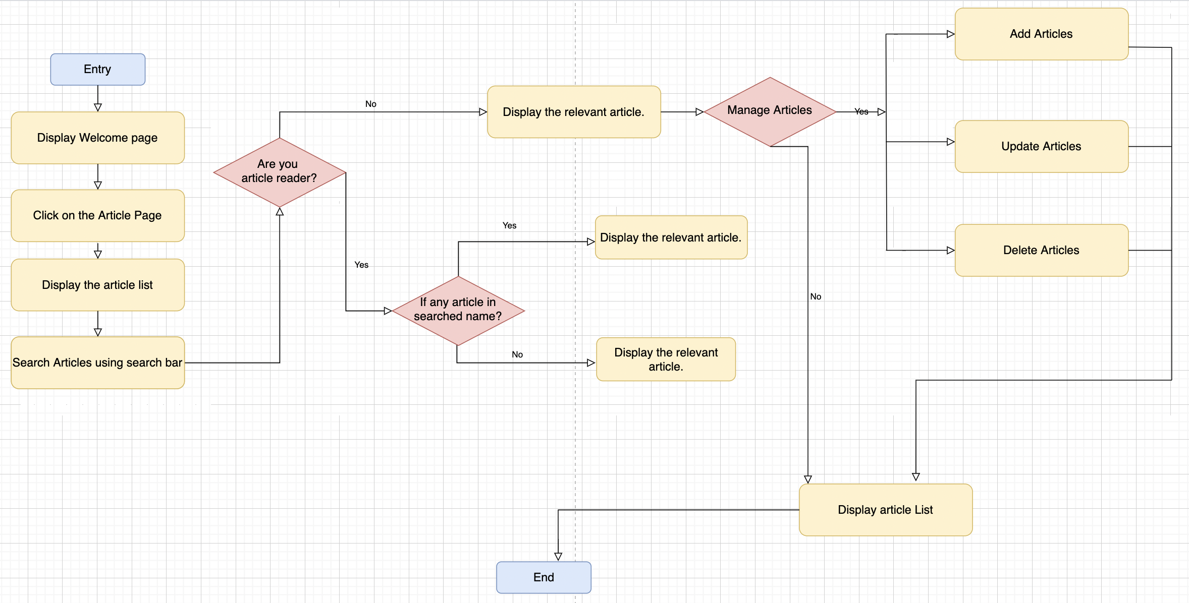

## **User Flow 3 –**

**Add giving ratings for articles Function**

**Thank You!!**